**CITIZENS PROTEST TO SAVE SATTAL**

Sattal registered its dissent on Twitter India by trending at #17 on 3rd July, 2021. The struggle of the locals was captured in the tag ‘SAVE SATTAL’ and pleaded against vested commercial interests at ecological costs.

The process of urbanization of the Sattal region in Uttarakhand for commercial interests has slowly been advancing at the cost of ecology, at lands that were once forests. Despite protests, sustainability is being compromised in the name of a ‘beautification and development project’.

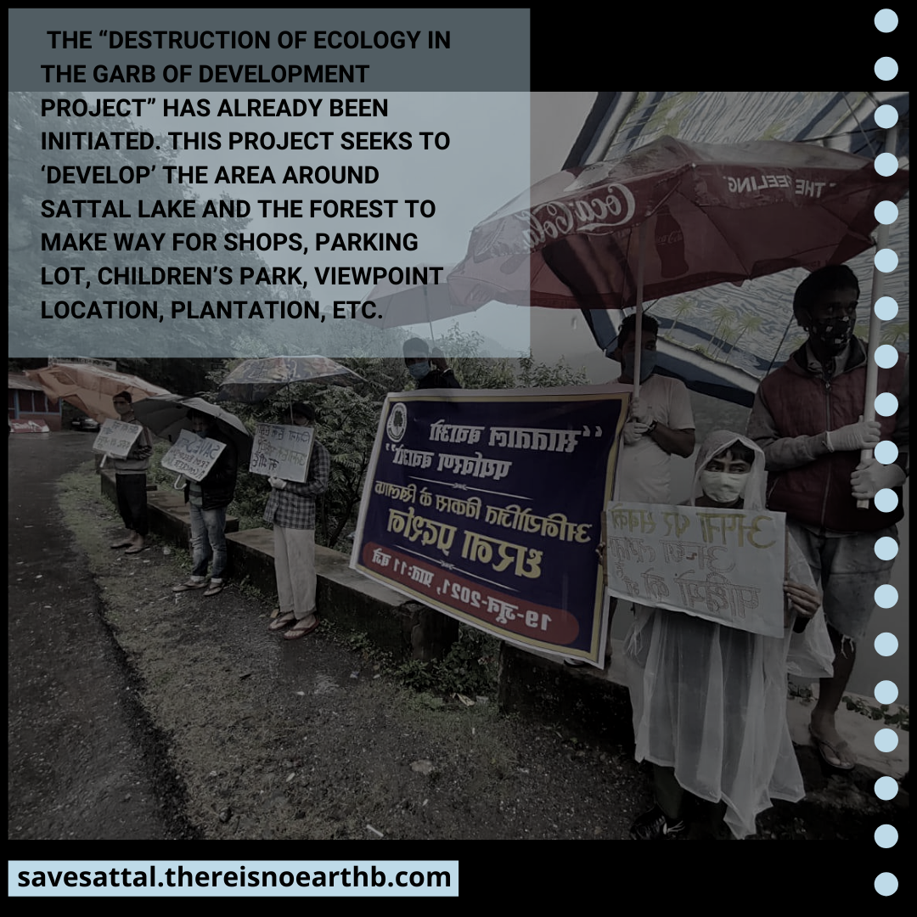

Locals and environmentalists have been attempting to register their angst against the ecologically unsustainable development plan by reaching out to local and other superior government authorities via the means of letters and petitions. However, the authorities have failed to acknowledge these concerns, and ‘destruction of ecology in the garb of development projects’ has already been initiated.

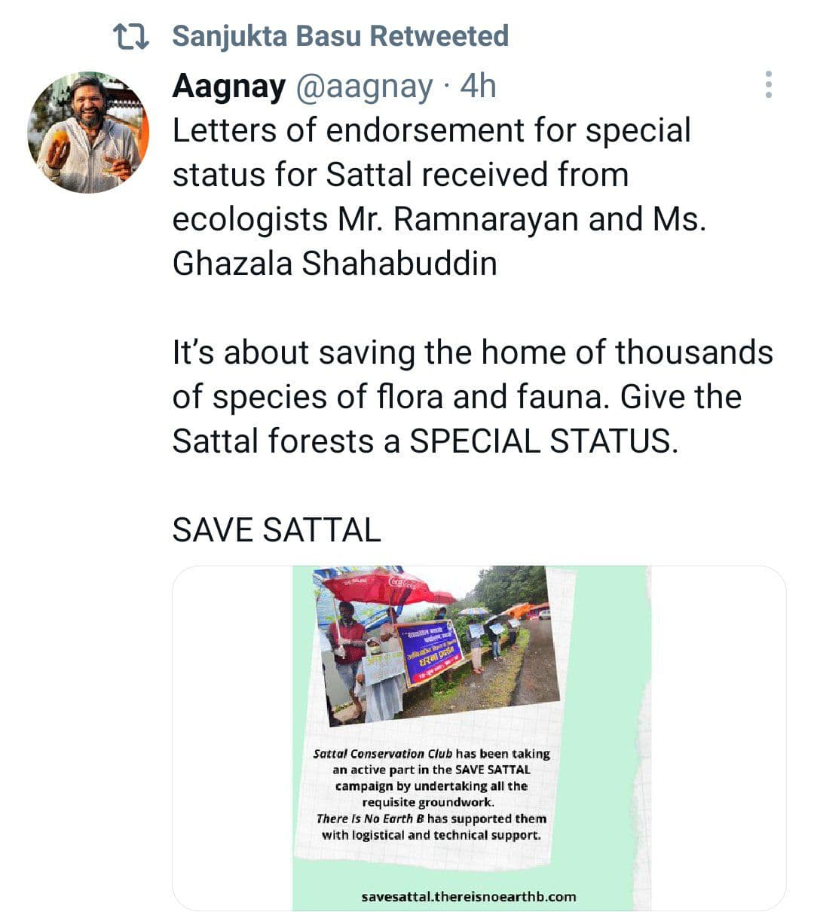

An ecologically important region, Sattal is home to over 525 varieties of butterflies and over 500 species of birds, it is also a refuge to high-quality oak-dominated hardwood forests that are currently endangered in the Kumaon region, due to pine invasion, fire, and fragmentation.

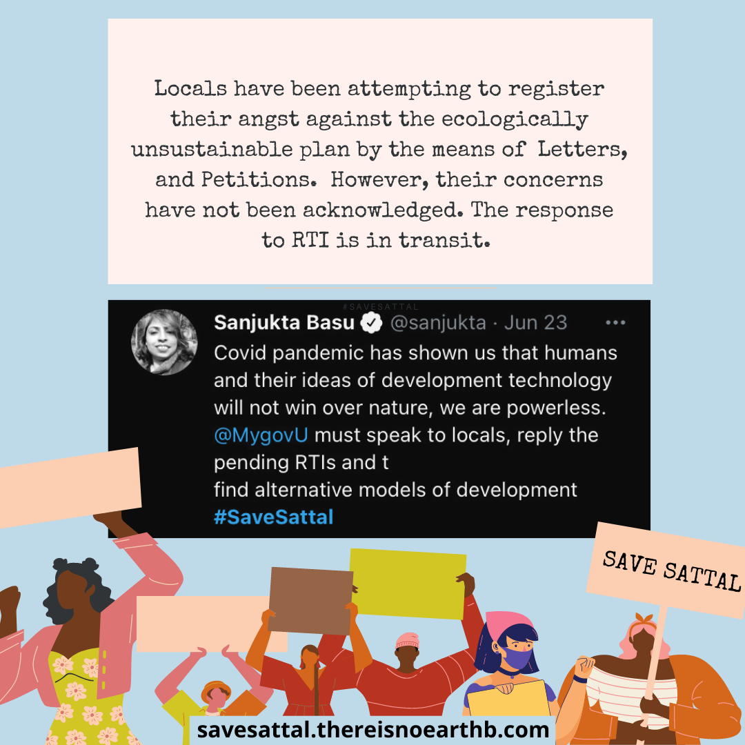

The project solicits ‘development’ of the area around Sattal lakes and forests clearing the way for the construction of shops, parking lot, children’s park, viewpoint location, plantation, etc. A birding center has also been proposed for the 500+ species of birds found in the area, environmentalists have warned that the concretization will be counterproductive leading to a decline in the number of species of birds found presently.

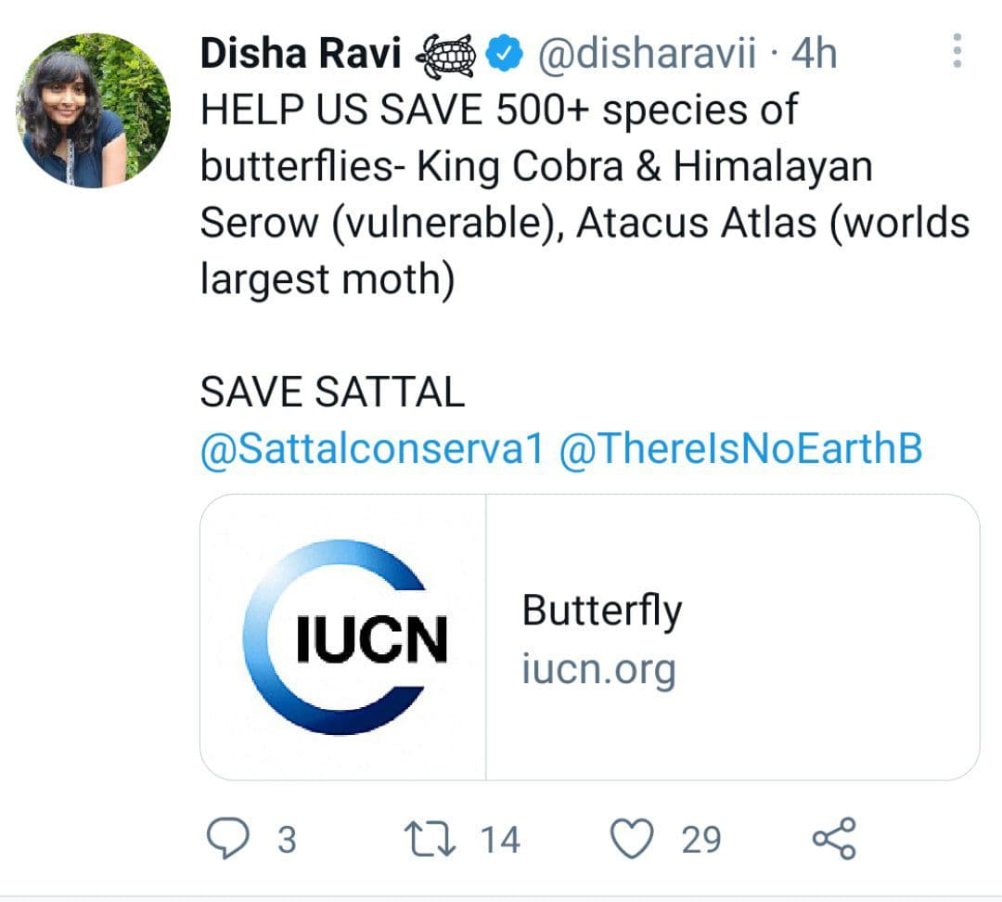

Additionally, new shops are being constructed in place of old ones, which might strip the livelihood of old and local shopkeepers. No information regarding the said project has been provided to the people who would be impacted directly, that is the people who live and work in that specific area.

In the face of this,  [SAVE SATTAL](https://savesattal.thereisnoearthb.com/) movement by the members of [Sattal Conservation Club](https://savesattal.thereisnoearthb.com/) has emerged, playing a leading role in actively running the campaign by undertaking all the requisite groundwork. Their efforts have been accentuated by [**There Is No Earth B**](https://thereisnoearthb.com/) who have been providing all the necessary technical and artistic support.

A resident of Sattal and member of [Sattal Conservation Club](https://savesattal.thereisnoearthb.com/), Aagnay Budhraja remarked, *“Destruction of nature is not necessarily a part and parcel of development… there is something beautiful and unique about Sattal which must remain as such and the old ideas of development cannot be allowed to overpower the natural beauty of this region”*

Despite the long withstanding peaceful protests by locals and environmentalists, a JCB had started the work to move the earth around the Sattal Lake site but was sent back in view of the mounting pressure. Locals fear that such a development project would compromise and violate the vast and beautiful ecology of the Sattal region which so far has managed to remain untouched and protected from the evil of concretization unlike other regions in the state of Uttarakhand.

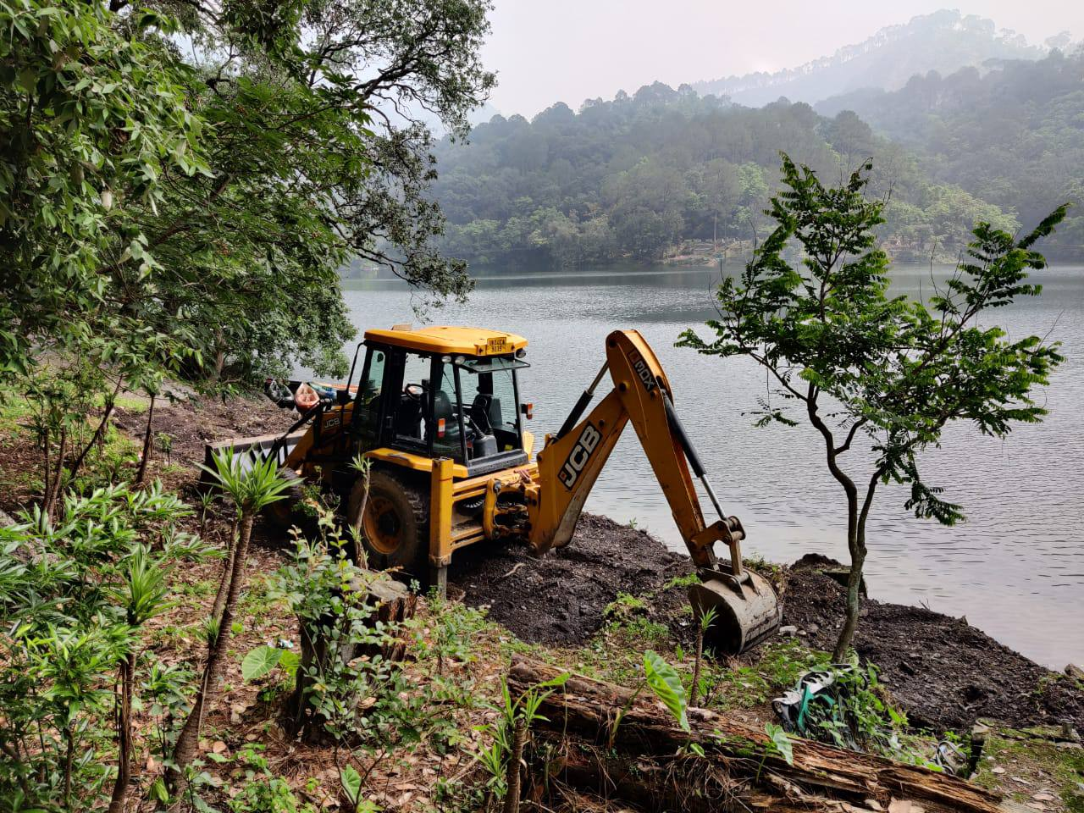

Locals believe that all hill stations do not need to follow the same model of development, and authorities must think creatively to strike a balance between development and ecological sustainability while maintaining transparency at each step. Local stakeholders and environmentalists are demanding authorities to give a special status to Sattal and withdraw their development project. A special status would empower the local citizens to be consulted and possibly stop the destruction of the natural habitat.

[SAVE SATTAL](https://savesattal.thereisnoearthb.com/), is a citizen’s movement led by the people of Sattal, aimed at protecting their homeland from the downside of development and beautification.

[There Is No Earth B](https://thereisnoearthb.com/), is a close ally of [the Sattal Conservation Club,](https://savesattal.thereisnoearthb.com/) and a community that aims to contribute towards the building of inclusive, organic, and decentralized Climate Action and Advocacy movements.

Both the communities do not have any political or religious affiliations.

Important Links :

Sattal Conservation Club:

https://savesattal.thereisnoearthb.com/

There Is No Earth B:

<https://thereisnoearthb.com/>

Petition link:

<https://www.change.org/p/cmo-uttarakhand-declare-the-sattal-forests-a-conservation-reserve>

**Some Tweets:**

[**https://twitter.com/disharavii/status/1411288282130878466?s=20**](https://twitter.com/disharavii/status/1411288282130878466?s=20)

[**https://twitter.com/Sattalconserva1/status/1409563372689891328?s=20**](https://twitter.com/Sattalconserva1/status/1409563372689891328?s=20)

[**https://twitter.com/ThereIsNoEarthB/status/1410923798883278849?s=20**](https://twitter.com/ThereIsNoEarthB/status/1410923798883278849?s=20)

[**https://twitter.com/Sattalconserva1/status/1410204026478620676?s=20**](https://twitter.com/Sattalconserva1/status/1410204026478620676?s=20)

[**https://twitter.com/Sattalconserva1/status/1409561521005293568?s=20**](https://twitter.com/Sattalconserva1/status/1409561521005293568?s=20)